**Yao and Lin 2017 – The mutual causality analysis between the stock and futures markets**

* **RQ**: Which way does information flow between Chinese stock and futures markets
* **Data**: Daily data of 2861 stocks and stock index futures spanning from April 16 2010 to December 31 2015. They obtain 1388 observations of each financial object in the market from this period. After removing the stocks that were officially listed after April 16 2010 on the Shanghai Stock exchange, they are left with 844 stocks on the Shanghai stock exchange. Finally the studied stocks consist of 844 stocks on Shanghai Stock Exchange and 902 stocks on Shenzhen Stock Exchange while the stock index futures include Shanghai and Shenzhen 300 ( Hushen 300) index futures, china Securities Index 500 (CSI500) futures and Shanghai Stock 50 ( SSE50 ) index futures.
* **Method**: They employ a granger causality test for each individual stock on its ability to granger cause hushen 300 index futures.   
    
    
  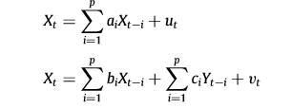

**Conditional Granger causality test**: Really cool but maybe not applicable here: they use this detect any other variation from other stocks that would cause indirect “causation” to the futures market. They try to find direct information flow.  
  
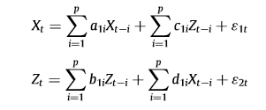  
  
*Note*: They first perform a stationarity analysis through an ADF-test and then, a heteroscedasticity analysis through modeling a GARCH model and adjusting the data.

* **Findings**: They find that the information flows from futures to stocks are slightly greater than stocks to futures. Also mentions that stock market volatility may contribute to fluctuations of information flows.





Bekiros, Diks 2001 - The relationship between crude oil spot and futures prices: Cointegration, linear and nonlinear causality

* **RQ**: What is the lead-lag relationship between crude oil spot and futures prices
* **Data**:
* **Method**:
* **Findings**:

Vargranger description  
  
